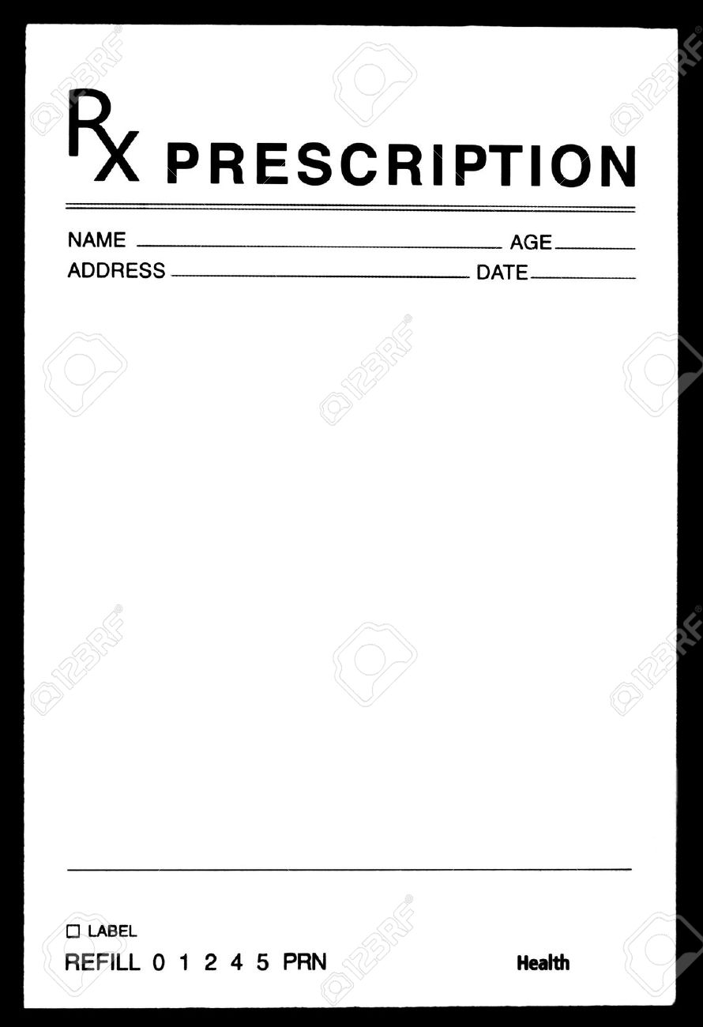

**NARCAN**

Nasal Spray: Narcan 4mg nasal spray

Use as directed

Dispense 1

Refill x3